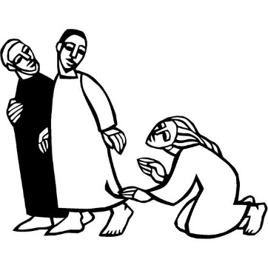
Third Sunday After Pentecost
June 11, 2023

Prelude

Words of Welcome

Entrance Hymn God himself is with us (Tysk)
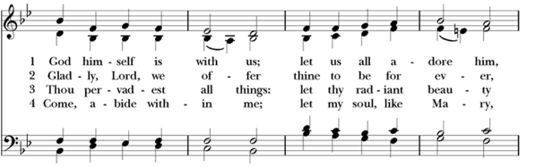
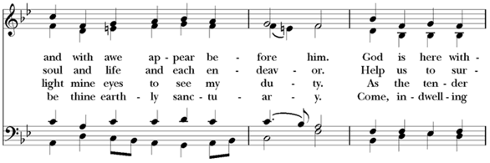
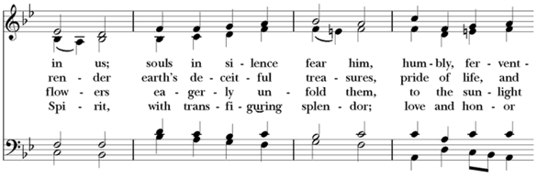
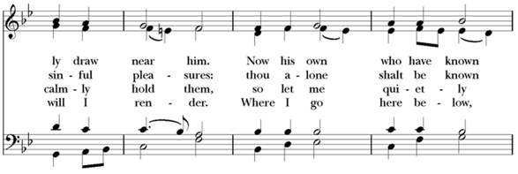
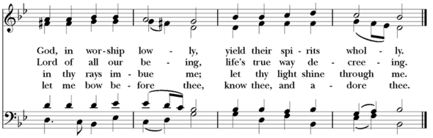

Opening Acclamation
Celebrant | Blessed be the one, holy, and living God.
People | Glory to God for ever and ever.

Almighty God, to you all hearts are open, all desires known, and from you no secrets are hid: Cleanse the thoughts of our hearts by the inspiration of your Holy Spirit, that we may perfectly love you, and worthily magnify your holy Name; through Christ our Lord. Amen.

Opening Anthem or Song of Praise MHSO 9 Gloria, gloria, in excelsis Deo! (Berthier)

THE COLLECT OF THE DAY
Celebrant | The Lord be with you.
People | And also with you.
Celebrant | Let us pray.

O God, from whom all good proceeds: Grant that by your inspiration we may think those things that are right, and by your merciful guiding may do them; through Jesus Christ our Lord, who lives and reigns with you and the Holy Spirit, one God, for ever and ever. Amen.

First Reading: Hosea 5:15--6:6
The people sit.
A Reading from the book of the prophet Hosea.
[Thus says the Lord:] ¹⁵“I will return again to my place
until they acknowledge their guilt and seek my face.
In their distress they will beg my favor:
^{6:1}‘Come, let us return to the Lord;
for it is he who has torn, and he will heal us;
he has struck down, and he will bind us up.
²After two days he will revive us;
on the third day he will raise us up,
that we may live before him.
³Let us know, let us press on to know the Lord;
his appearing is as sure as the dawn;
he will come to us like the showers,
like the spring rains that water the earth.’
⁴What shall I do with you, O Ephraim?
What shall I do with you, O Judah?
Your love is like a morning cloud,
like the dew that goes away early.
⁵Therefore I have hewn them by the prophets,
I have killed them by the words of my mouth,
and my judgment goes forth as the light.
⁶For I desire steadfast love and not sacrifice,
the knowledge of God rather than burnt offerings.”

Reader | Hear what the Spirit is saying to God’s people.
People | Thanks be to God.

Silence may follow.

PSALM 33: 1-12
Responsively by whole verse (Alternate with the lector)

1 Rejoice in God, you righteous; *
it is good for the just to sing praises.
2 Praise God with the harp; *
play upon the psaltery and lyre.
3 Sing for God a new song; *
sound a fanfare with all your skill upon the trumpet.
4 For your word, O God, is right, *
and all your works are sure.
5 You love righteousness and justice; *
your loving-kindness fills the whole earth.
6 By your word, O God, were the heavens made, *
by the breath of your mouth all the heavenly hosts.
7 You gather up the waters of the ocean as in a water-skin *
and store up the depths of the sea.
8 Let all the earth fear you; *
let all who dwell in the world stand in awe of you.
9 For you spoke, and it came to pass; *
you commanded, and it stood fast.
10 You bring the will of the nations to naught *
and thwart the designs of the peoples.
11 But your will stands fast for ever, *
and the designs of your heart from age to age.
12 Happy is the nation that worships you, O Most High; *
happy the people you have chosen to be your own!

Second Reading: Romans 4:13-25
A Reading from Paul's letter to the Church in Rome.
¹³The promise that he would inherit the world did not come to Abraham or to his descendants through the law but through the righteousness of faith. ¹⁴If it is the adherents of the law who are to be the heirs, faith is null and the promise is void. ¹⁵For the law brings wrath; but where there is no law, neither is there violation.
¹⁶For this reason it depends on faith, in order that the promise may rest on grace and be guaranteed to all his descendants, not only to the adherents of the law but also to those who share the faith of Abraham (for he is the father of all of us, ¹⁷as it is written, “I have made you the father of many nations”)—in the presence of the God in whom he believed, who gives life to the dead and calls into existence the things that do not exist. ¹⁸Hoping against hope, he believed that he would become “the father of many nations,” according to what was said, “So numerous shall your descendants be.” ¹⁹He did not weaken in faith when he considered his own body, which was already as good as dead (for he was about a hundred years old), or when he considered the barrenness of Sarah’s womb. ²⁰No distrust made him waver concerning the promise of God, but he grew strong in his faith as he gave glory to God, ²¹being fully convinced that God was able to do what he had promised. ²²Therefore his faith “was reckoned to him as righteousness.” ²³Now the words, “it was reckoned to him,” were written not for his sake alone, ²⁴but for ours also. It will be reckoned to us who believe in him who raised Jesus our Lord from the dead, ²⁵who was handed over to death for our trespasses and was raised for our justification.

Reader | Hear what the Spirit is saying to God’s people.
People | Thanks be to God.

Gospel Acclamation Hallelujah (Maraire) (MHSO 19)

Gospel: Matthew 9:9-13, 18-26
All stand.
Priest | The Holy Gospel of our Lord Jesus Christ according to Matthew.
People | Glory to you, Lord Christ.

⁹As Jesus was walking along, he saw a man called Matthew sitting at the tax booth; and he said to him, “Follow me.” And he got up and followed him.
¹⁰And as he sat at dinner in the house, many tax collectors and sinners came and were sitting with him and his disciples. ¹¹When the Pharisees saw this, they said to his disciples, “Why does your teacher eat with tax collectors and sinners?” ¹²But when he heard this, he said, “Those who are well have no need of a physician, but those who are sick. ¹³Go and learn what this means, ‘I desire mercy, not sacrifice.’ For I have come to call not the righteous but sinners.”
¹⁸While he was saying these things to them, suddenly a leader of the synagogue came in and knelt before him, saying, “My daughter has just died; but come and lay your hand on her, and she will live.” ¹⁹And Jesus got up and followed him, with his disciples. ²⁰Then suddenly a woman who had been suffering from hemorrhages for twelve years came up behind him and touched the fringe of his cloak, ²¹for she said to herself, “If I only touch his cloak, I will be made well.” ²²Jesus turned, and seeing her he said, “Take heart, daughter; your faith has made you well.” And instantly the woman was made well. ²³When Jesus came to the leader’s house and saw the flute players and the crowd making a commotion, ²⁴he said, “Go away; for the girl is not dead but sleeping.” And they laughed at him. ²⁵But when the crowd had been put outside, he went in and took her by the hand, and the girl got up. ²⁶And the report of this spread throughout that district.

Priest | The Gospel of the Lord.
People | Praise to you, Lord Christ.

The Sermon

The Creed
We believe in one God,
the Father, the Almighty,
maker of heaven and earth,
of all that is, seen and unseen.
We believe in one Lord, Jesus Christ,
the only Son of God,
eternally begotten of the Father,
God from God, Light from Light,
true God from true God,
begotten, not made,
of one Being with the Father.
Through him all things were made.
For us and for our salvation
he came down from heaven:
by the power of the Holy Spirit
he became incarnate from the Virgin Mary,
and was made man.
For our sake he was crucified under Pontius Pilate;
he suffered death and was buried.
On the third day he rose again
in accordance with the Scriptures;
he ascended into heaven
and is seated at the right hand of the Father.
He will come again in glory to judge the living and the dead,
and his kingdom will have no end.
We believe in the Holy Spirit, the Lord, the giver of life,
who proceeds from the Father and the Son.
With the Father and the Son he is worshiped and glorified.
He has spoken through the Prophets.
We believe in one holy catholic and apostolic Church.
We acknowledge one baptism for the forgiveness of sins.
We look for the resurrection of the dead,
and the life of the world to come. Amen.

The Prayers of the People

Confession of Sin
Let us confess our sins to God.
God of all mercy,
we confess that we have sinned against you,
opposing your will in our lives.
We have denied your goodness in each other,
in ourselves, and in the world you have created.
We repent of the evil that enslaves us,
the evil we have done,
and the evil done on our behalf.
Forgive, restore, and strengthen us
through our Savior Jesus Christ,
that we may abide in your love
and serve only your will. Amen.
Almighty God have mercy on us, forgive us all our sins through the grace of Jesus Christ, strengthen us in all goodness, and by the power of the Holy Spirit keep us in eternal life. Amen.

The Peace
All stand.
Celebrant | The peace of the Lord be always with you.
People | And also with you.
Then the Ministers and the People may greet one another in the name of the Lord.

Announcements

THE HOLY COMMUNION

Offertory Sentence
Let us with glad hearts offer the fruits of our life and labor to the Lord.

Offertory Hymn I Love To Tell the Story

THE GREAT THANKSGIVING

The People remain standing.
Celebrant | The Lord be with you.
People | And also with you.
Celebrant | Lift up your hearts.
People | We lift them to the Lord.
Celebrant | Let us give thanks to the Lord our God.
People | It is right to give our thanks and praise.

It is right, and a good and joyful thing, always and everywhere to give thanks to you, Almighty God, Creator of heaven and earth.
For by water and the Holy Spirit you have made us a new people in Jesus Christ our Lord, to show forth your glory in all the world.
Therefore we praise you, joining our voices with Angels and Archangels and with all the company of heaven, who for ever sing this hymn to proclaim the glory of your Name:

Sanctus Santo, santo, santo [Holy, holy, holy] (WLP 785)
The People stand or kneel.
The Celebrant continues
Holy and gracious God: In your infinite love you made us for yourself; and, when we had fallen into sin and become subject to evil and death, you, in your mercy, sent Jesus Christ, your only and eternal Son, to share our human nature, to live and die as one of us, to reconcile us to you, the God and maker of all.
He stretched out his arms upon the cross, and offered himself in obedience to your will, a perfect sacrifice for the whole world.
On the night he was handed over to suffering and death, our Lord Jesus Christ took bread; and when he had given thanks to you, he broke it, and gave it to his disciples, and said, “Take, eat: This is my Body, which is given for you. Do this for the remembrance of me.”
After supper he took the cup of wine; and when he had given thanks, he gave it to them, and said, “Drink this, all of you: This is my Blood of the new Covenant, which is shed for you and for many for the forgiveness of sins. Whenever you drink it, do this for the remembrance of me.”
Therefore we proclaim the mystery of faith:
Celebrant and People
Christ has died.
Christ is risen.
Christ will come again.

We celebrate the memorial of our redemption, Almighty God, in this sacrifice of praise and thanksgiving. Recalling his death, resurrection, and ascension, we offer you these gifts.
Sanctify them by your Holy Spirit to be for your people the Body and Blood of your Son, the holy food and drink of new and unending life in him. Sanctify us also that we may faithfully receive this holy Sacrament, and serve you in unity, constancy, and peace; and at the last day bring us with all your saints into the joy of your eternal kingdom.
All this we ask through your Son Jesus Christ. By him, and with him, and in him, in the unity of the Holy Spirit all honor and glory is yours, Almighty God, now and for ever. AMEN.

THE LORD’S PRAYER
As our Savior Christ has taught us, we now pray,
People and Celebrant
Our Father in heaven,
hallowed be your Name,
your kingdom come,
your will be done, on earth as in heaven.
Give us today our daily bread.
Forgive us our sins
as we forgive those who sin against us.
Save us from the time of trial
and deliver us from evil.
For the kingdom, the power,
and the glory are yours,
now and forever. Amen.

THE BREAKING OF THE BREAD

Alleluia. Christ our Passover is sacrificed for us;
Therefore let us keep the feast. Alleluia.
The Gifts of God for the People of God. Take them in remembrance that Christ died for you, and feed on him in your hearts by faith, with thanksgiving.

The Body and Blood of our Lord Jesus Christ keep us in everlasting life. Amen.

Spiritual Communion
For those remaining at home, a Spiritual Communion is offered. This is a personal devotion that anyone can pray (at any time) to express their desire to receive Holy Communion at that moment, but in which circumstances prevent them from receiving the elements.
For those worshipping with us from home, we pray together with you:
Lord Jesus, I believe that you are truly present in the Holy Sacrament, and, since I cannot at this time receive communion, I pray you to come into my heart. I unite myself with you and embrace you with all my heart, my soul, and my mind. Let nothing separate me from you. By the power of the Holy Spirit, may I embody your grace and be renewed for your service. Amen.

Post-Communion Prayer
Let us pray.
Loving God,
we give you thanks
for restoring us in your image
and nourishing us with spiritual food
in the Sacrament of Christ’s Body and Blood.
Now send us forth
a people, forgiven, healed, renewed;
that we may proclaim your love to the world
and continue in the risen life of Christ our Savior. Amen.

Sending Forth
We send you forth bearing these holy gifts, that those to whom you go may share with us in the Body and Blood of Christ.
We who are many are one Body, for we all share in the one bread and the one cup.

Post-Communion Hymn Come, thou fount of every blessing

DISMISSAL
 | Go in peace to love and serve the Lord.
People | Thanks be to God.

POSTLUDE

Serving today:
Ministers of Music: Dennis Flynn
Lector: Carol Lauffer Prayers: Jennifer Dingman
Presider: Rev. Diane Stier Director: Alice Ciccu
Greeters: Clancy & Patricia DeLong Acolyte: Adam Baker
Coffee Hour Hosts: David & Jennifer Dingman

St. John’s Episcopal Church
206 West Maple Street
Mount Pleasant, MI 48858
989.773.7448
E-mail: saintjohnsmp@gmail.com
Website: www.stjohnsmtpleasantmi.com
The Rev. Sr. Diane Stier, ec, Rector
Dr. Nancy Herman Kinney, Senior Warden
Clancy DeLong, Treasurer

St. John’s Episcopal Church is a parish of the
Episcopal Diocese of Western Michigan
The Rt. Rev. Prince Singh, Bishop Provisional
The Episcopal Church
The Most Rev. Dr. Michael B. Curry, Presiding Bishop
The Worldwide Anglican Communion
The Most Rev. Dr. Justin Welby, Archbishop of Canterbury

From riteplanning.com.
Copyright © 2023 Church Publishing Inc. All rights reserved.
All music is reprinted with permission. Print and Streaming: OneLicense.net license # A-727547, CCLI #3146185
Prayers are taken or adapted from the Book of Common Prayer, Enriching our Worship, the Book of Occasional Services 2018, and the New Zealand Prayer Book

++++++++++++++++++++++++

Pop Up Pride in the Park

Join us in celebrating, uplifting, and advocating for our regional 2SLGBTQIA+ community at the 2nd Pop Up Pride in the Park at Broadway Park in Mount Pleasant. We’re excited to welcome food trucks, a Two-Spirit presentation, local 2SLGBTQIA+ vendors, and community resources!

Saturday, June 10, 2023
5:30 P.M. – 9:00 P.M.
Broadway Park
2451 Nish Na Be Anong Rd
Mt Pleasant, MI 48858

St. John's will have a booth at this event. If you are interested in volunteering, please contact the Parish Office for more information.

++++++++++++++++++++++++

St. John’s Annual Rummage Sale

It’s that time of year, start collecting your unwanted treasures and items you no longer need. Items of great interest include furniture, tools, small kitchen appliances, and baby items. We can also use children’s clothes up to age 12. No adult clothes though, please take them to the ICDC Thrift Store or Goodwill.

Important Dates:

June 11- 20 – Collection Days – please bring your items to the Lantern.
June 17 – 21 – Pricing Days
June 21 – Early Bird Shopping for St. John’s Parishioners only
June 22 – 24 – RUMMAGE SALE!

If you want to help with setup, pricing, or the actual sale, please contact Alice (aciccu@hotmail.com) or the office

We pray this week…

For Michael, Presiding Bishop; Prince, our Bishop Provisional, and for our diocese; and Bonnie, Bishop of Michigan, Rayford, Bishop of Northern Michigan.

For Moisés, Bishop of the Dominican Republic

For Justin, Archbishop of Canterbury

For Craig, Bishop of ELCA.

For The Anglican Church of Melanesia

For Joe, our President; Gretchen, our Governor; and all who make decisions for this nation.

For Diane, our Rector; Dennis, our Organist; Eric, our Choirmaster

For all those in our diocese discerning calls to ministry, especially Joe, Barrett, Matt, and Anne Marie

For our lay ministers, lectors, choir, acolytes, greeters, and hospitality hosts

For all non-parochial clergy and Lutheran pastors serving in our congregations
For Calvary, Hillman - Dana Howard, Sr. Warden

For St. Peter’s Seasonal Chapel, Lake Leelanau – Charles Bennison, Vicar

For Emmaus Monastery, Vestaburg – Srs. Diane Stier and Linda-Susan Beard

For the members of St. John’s, especially those celebrating birthdays this week: Jessica

For the members of St. John’s especially: Sharon, Sierra, Sondra, Tom, Mary Ellen, Ulana & Victoria

For those on the Prayer Group’s list, especially Alma, Amy, Bill, Brent, Diane, Gabriel, Jess, Kathy, Nancy, Sarah and the child she carries, Therese, Tom, Tony

For all who have died

